**Register no**:1518102072

**Exercise no**:2

**Date:**16.10.2020

**Aim**:

To print the count number x in a given list of numbers.

**Program:**

def count(lst,x):

count = 0

for ele in lst:

if ele == x :

count=count+1

print(count)

lst =[]

n = int(input())

for i in range (0,n):

ele = int(input())

lst.append (ele)

x = int(input ())

count(lst,x)

**Link:**

[**http://103.53.53.18/mod/vpl/forms/submissionview.php?id=230&userid=1686**](http://103.53.53.18/mod/vpl/forms/submissionview.php?id=230&userid=1686)

**Output:**

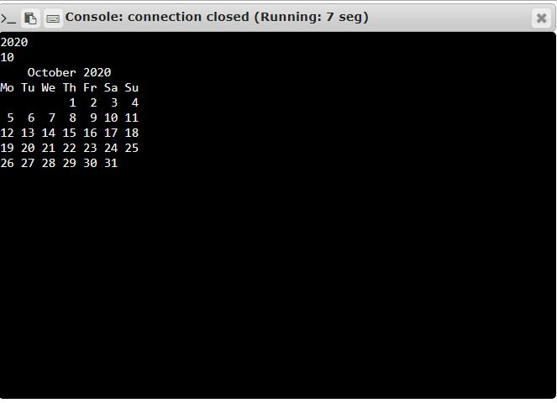

**Result:**

Thus the code has been executed successfully and the output is verified.